# Adding Error Handling to REST Calls

To diagnose errors with REST or OData calls you must add error handling. This note describes how add error handling and how to diagnose errors.

## Add Error Handling

The first step is the right-click the Call REST, Get list or Get entry activity and select Set error handling…

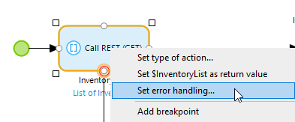

Choose Custom with rollback.

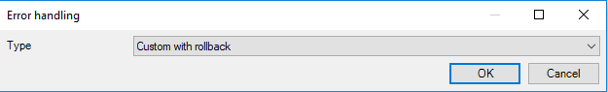

### SAP OData Request

If you are using a SAP OData Connector Get list or Get entry activity you can use the Get Latest HTTP Response activity to retrieve the response from the server. Drag down from the border of the Get list or Get entiry activity and add an activity. Configure the activity as a Get latest HTTP response. Next drag out from this activity and add an End event.

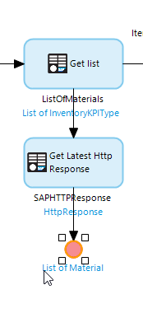

Right-click the line between the Call REST activity and the Get Latest Http Response activity and select Set as error handler.

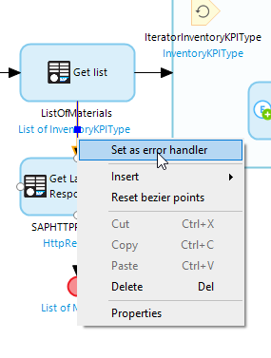

If you are getting errors in a REST call, right click the Get Latest HTTP Response activity and add a breakpoint. The red dot indicates an activate breakpoint.

|  |  |
| --- | --- |
|  |  |
|  |  |

### Call REST Request

If you are using a Call REST activity, you can’t use the Get Latest HTTP Response activity so simply add an End event for the error handler.

## Diagnosing Errors

Run the app and perform the function that will invoke the microflow. The microflow will pause when it reaches the activity with the breakpoint. You can then look at the Variables tab in the Mendix Modeler and exam the error messages.

One helpful variable is the latestError object. In the image below the Message property indicates the server returned a 401 error which means the authentication credentials were rejected.

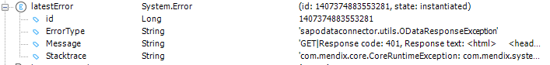

If you use the Get Latest HTTP Response activity the response will be generated with the name you configured on the activity. The image below shows the same 401 error.

